**Introduction to Modules**  
* A brand new feature in Java 9.  
**Java Platform Module System - JPMS  
=> Module as a container of packages.  
(Package contains classes, interfaces, and so on)**

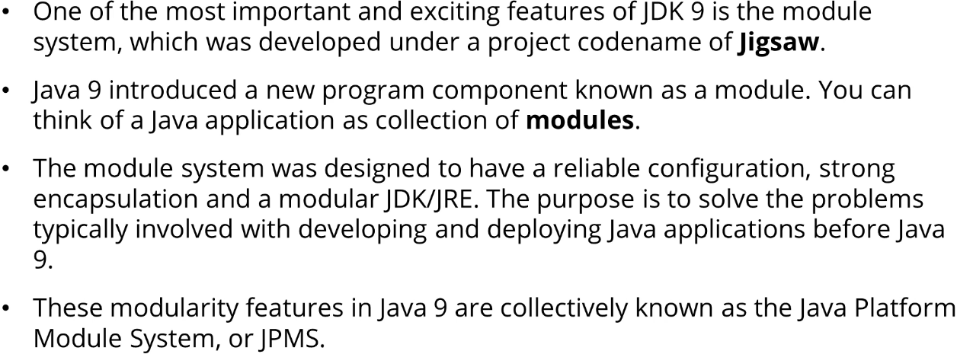

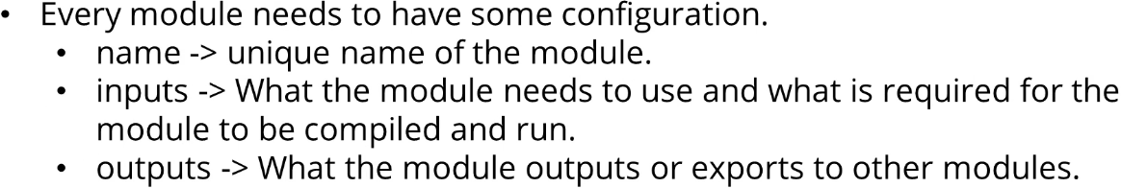



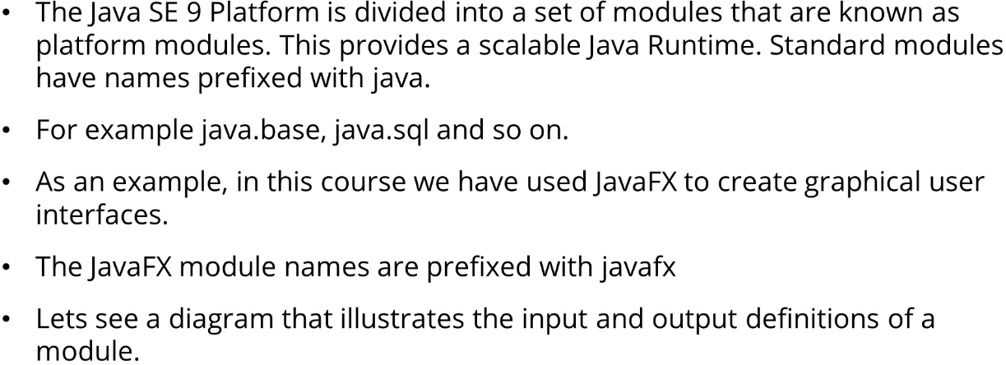

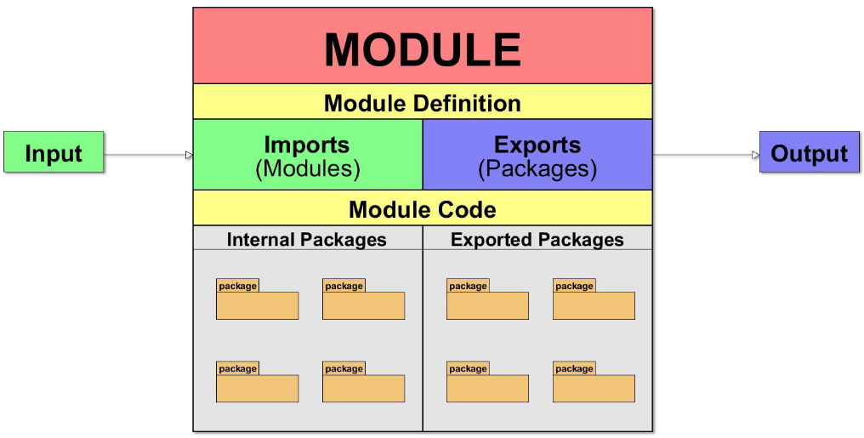  
* We also have external packages.

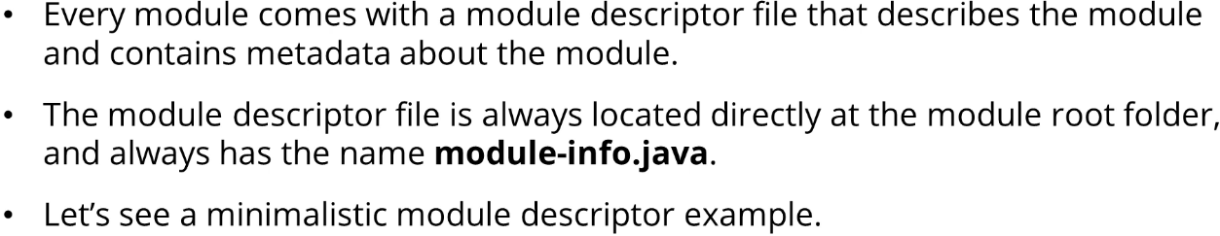

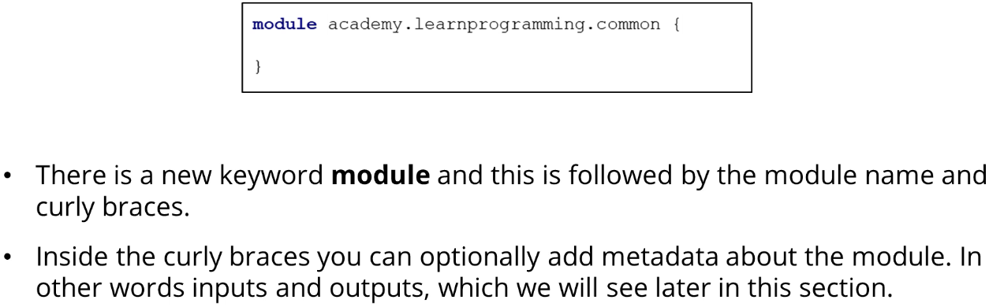

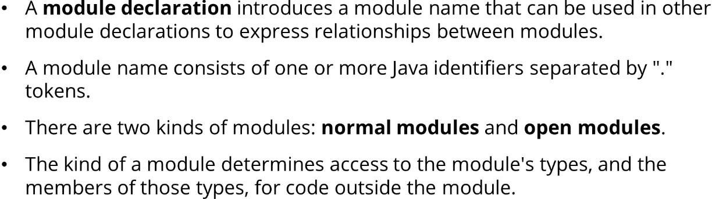

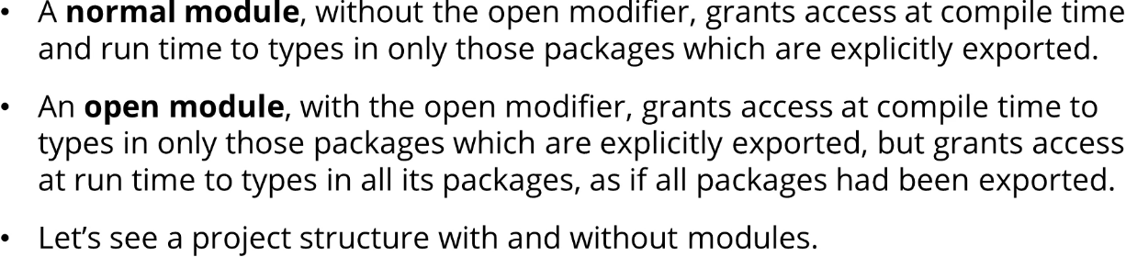

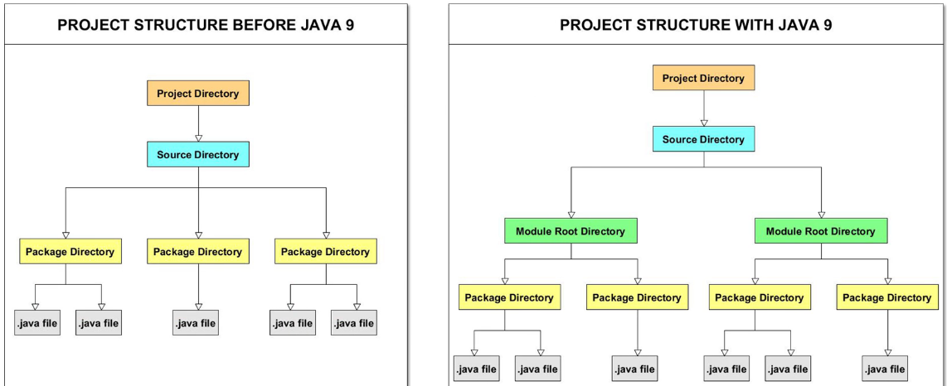  
* Before Java 9 we had a source directory with packages that contained java files.  
* With Java 9 there’s another directory - module root directory which will contain module-info.java which we talked about as well as package directories.  
* With Java 9 modular programming we don’t have to build applications as one big Java project.  
=> We can create modular units that work together to form an application.  
=> So modules are ideally components that are reusable, that solve specific requirements for that app.

* So you can think of modules as high level packages, keep in mind they’re not actually packages.

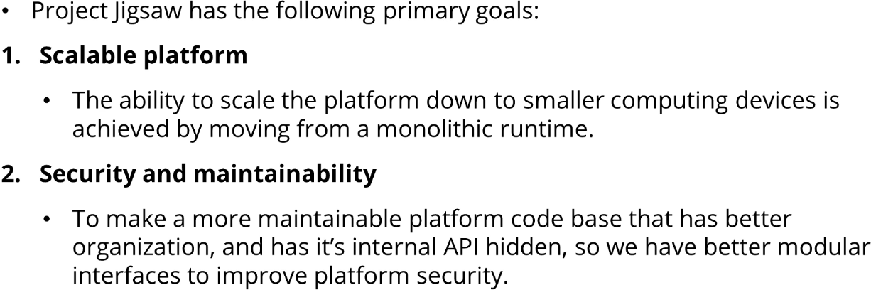

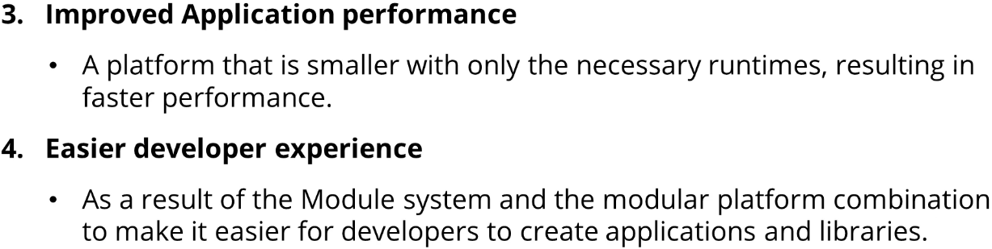

**Module Declarations and Statements**

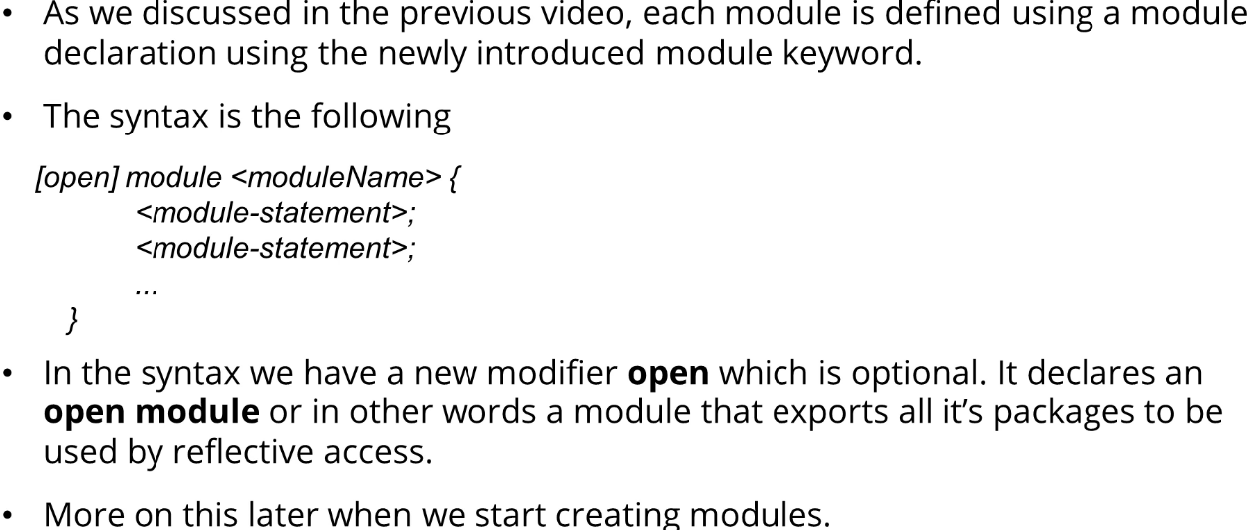

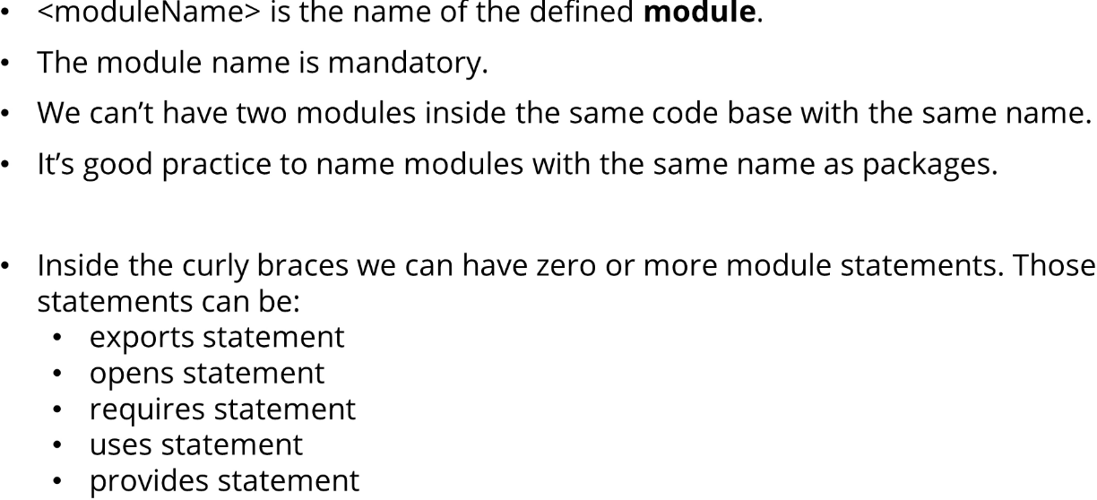

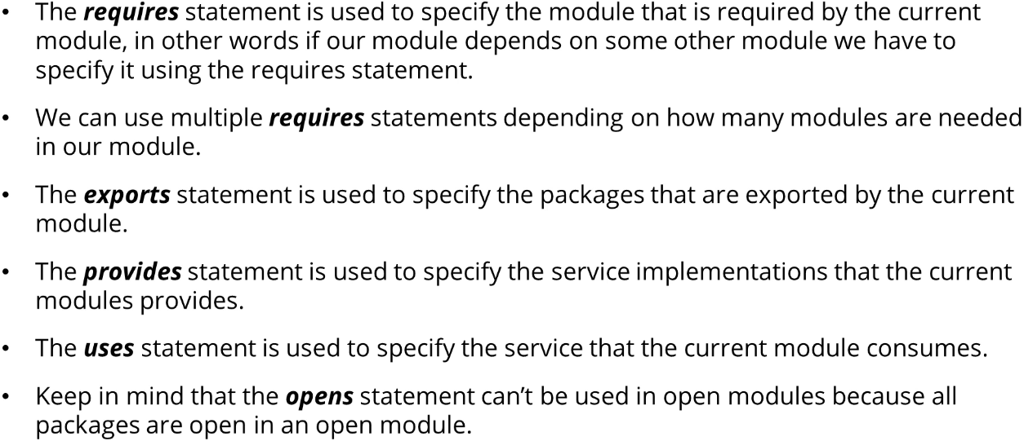

**Module Types**  
